
National University of Computer and Emerging Sciences

Software Engineering

“Deliverable {3} – {Scheduling Management System}”

STUDENTS NAME and REGISTRATION NUMBERS:
Ali Hamza (Team Lead) 21I-1107
Musa Haroon 21I-1206
Aiyza Junaid 21I-1145
Muneer Ahmed 21I-1179
DEGREE PROGRAM: BSSE
SECTION: P
SUBJECT NAME: Software Engineering
DATE OF SUBMISSION: April 25, 2022
SUBMITTED TO: Mr. Bilal Khalid Dar

STUDENT SIGNATURE:
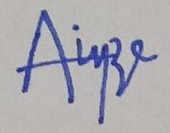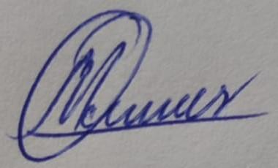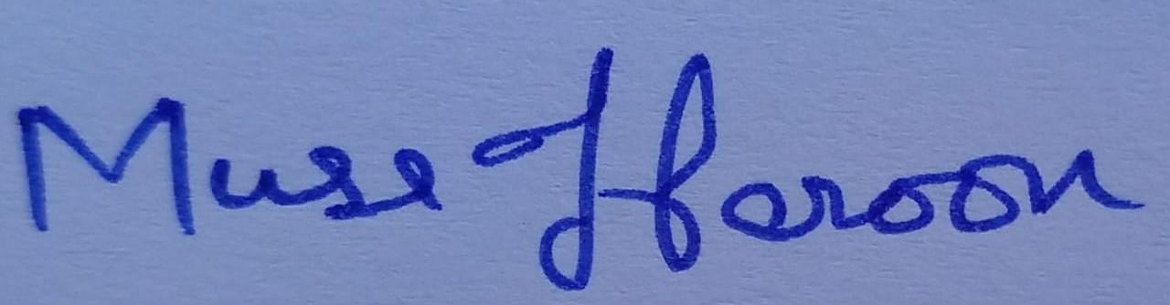
______________________________________________________________
MARKS:

______________________________________________________________
REMARKS:

______________________________________________________________
TEACHERS SIGNATURE:

______________________________________________________________
Contents

- Project Title and Introduction 3
- Sprint Backlog of Iteration 1 3
- Sprint Backlog of Iteration 2 14
- User Stories of Iteration 3 25
- Design 35
- Architecture 43
- Implementation 44
- Burn Down Chart 48
- Scrum Board 48
- Boundary value Analysis 50
- Work Division 107
- Lesson Learnt 108

- Project Title and Introduction:

Project Title: CatchUp

Introduction:
Are you always procrastinating? Are you someone who’s late in finishing your tasks? Fear no more, because now you’ll have all your worries sorted with our scheduling website, CatchUp, which will help you manage and track your assignments and quizzes. Our management system will provide you with features that will range from alerting you when a new task is uploaded. It will also sort your schedule for you on the basis of task submission in priority. You can also track your progress, visually with the help of a graph. Now you’ll never miss an upcoming event because you can view and edit your custom calendar with all your essential dates highlighted.

- User Stories:

Sprint Backlog of Iteration 1:

Story ID: 1 Story Title: Sign up using Google/Facebook
User Story: As a student, I want to be able to sign up for Student Diary App using my existing Google or Facebook accounts for easy access.
Acceptance Criteria:
And I know I am done when I can create an account to access the student diary using my Google/GB credentials, without having to create a new username and password.

Story ID: 2 Story Title: reCAPTCHA verification
User Story: As an admin, I want users to use reCAPTCHA when logging in to protect the website/web app from spam and abuse.
Acceptance Criteria:
And I know I am done when the user cannot login to their account unless they have been verified by the reCAPTCHA.

Story ID: 3 Story Title: Manual sign up
User Story: As a student, I want to be able to sign up for the Student Diary App by using my basic information like username , email and password.
Acceptance Criteria:
And I know I am done when I can create an account to access the student diary using basic information like username, email and password.

Story ID: 4 Story Title: Agree to terms and conditions
User Story: As an admin, I want users to agree to the terms and conditions before signup so that they come to know about our terms.
Acceptance Criteria:
And I know I am done when the user cannot sign up to their account unless they have agreed to the conditions.

Story ID: 5 Story Title: Have an account
User Story: As a student, I want that if I already have an account I can go to the login page so I can continue my login process.
Acceptance Criteria:
And I know I am done when I can go to the login page if I already have an account.

Story ID: 6 Story Title: Create an email
User Story: As an admin, I want the user to create an email if he doesn't have so he can continue to sign up.
Acceptance Criteria:
And I know I am done when the user can create an email through the link.

Story ID: 7 Story Title: Basic Login
User Story: As a student, I want to be able to log into my account using my username and password to access my data.
Acceptance Criteria:
And I know I am done when I can view my dashboard and all my assignments data after entering my username and password on the login screen.

Story ID: 8 Story Title: Forgot password feature
User Story: As a student, I want to be able to follow a procedure to reset my password in case I forget it or lose access to my account.
Acceptance Criteria:
And I know I am done when I receive an email on the email account associated with my Student Diary profile with a link to reset my password or i am successfully able to change password through backup key.

Story ID: 9 Story Title: Save password
User Story: As a student, I want to save my password for future use so I do not have to enter my password again and again.
Acceptance Criteria:
And I know I am done when I can save my password.

Story ID: 10 Story Title: Login through saved password
User Story: As a student, I want to login to my account by using a saved password so I can access my account quickly.
Acceptance Criteria:
And I know I am done when I can login to my account by using a saved password.

Story ID: 11 Story Title: Create an account
User Story: As a student, I want to have an option of creating a new account on the login page so I can create a new account.
Acceptance Criteria:
And I know I am done when I will move to the sign up page.

Story ID: 12 Story Title: Show password
User Story: As a student, I want an option to see my password if I want to see it during the login process so I can avoid errors.
Acceptance Criteria:
And I know I am done when I have an option to see my password during the login process.

Story ID: 13 Story Title: Upload Assignment and Quiz Dates
User Story: As a student, I want to upload assignment and quiz dates so that I can view all the important dates in one place.
Acceptance Criteria:
And I know I am done when I can view all my assignment dates.

Story ID: 14 Story Title: Date Format for Assignments and Quizzes
User Story:
As a student, I want to add my assignments and quiz dates in day/month/year format so that I know what format to use.
Acceptance Criteria:
And I know I am done when I can view all my assignments and quiz dates in day/month/year format.

Story ID: 15 Story Title: Upload Assignment and Quiz Topics
User Story:
As a student, I want to upload the topics of my assignments and quizzes so that I know which topics are included.
Acceptance Criteria:
And I know I am done when I can view all my topics.

Story ID: 16 Story Title: Add Notes to Assignments and Quizzes
User Story:
As a student, I want to add additional notes in a text box for assignments and quizzes so that it’s easier to navigate through the content.
Acceptance Criteria:
And I know I am done when I can view all my notes.

Story ID: 17 Story Title: Character limit for inputs
User Story:
As a student, I want to know the character limit of my inputs so that I know how much I can write in the text box.
Acceptance Criteria:
And I know I am done when the system limits me from writing out of the limit of 280 characters.

Story ID: 18 Story Title: Mark assignments and quizzes that are complete
User Story:
As a student, I want to mark the assignments and quizzes that have been completed so that I know how much work is left.
Acceptance Criteria:
And I know I am done when I can see the completed assignments and quizzes have been marked.

Story ID: 19 Story Title: Add Marks to Assignments and Quizzes
User Story:
As a student, I want to enter the marks for the assignments and quizzes that have been checked so that I can view my results in one place.
Acceptance Criteria:
And I know I am done when I can view all my marks on screen.

Story ID: 20 Story Title: Drop-down menu to select subjects
User Story:
As a student, I want to select my subjects from a drop-down menu so that my assignments and quizzes are arranged subject wise.
Acceptance Criteria:
And I know I am done when I can view all my subjects in the drop-down menu.

Sprint Backlog of Iteration 2:

Story ID: 1 Story Title: Add Personal Information
User Story:
As a student, I want to add my personal information such as name, date of birth and email so that my personal information is stored in the account.
Acceptance Criteria:
And I know I am done when I can view all my personal information on the profile page.

Story ID: 2 Story Title: Add Course Information
User Story:
As a student, I want to add my course information so that my course information is stored in the account.
Acceptance Criteria:
And I know I am done when I can view all the subject pages.

Story ID: 3 Story Title: Mark Calendar
User Story:
As a student, I want to mark important assignments and quiz dates on the calendar so that I know when all assignments and quizzes are due.
Acceptance Criteria:
And I know I am done when I can view all my assignments and quiz dates marked on the calendar.

Story ID: 4 Story Title: Color Coded Subjects
User Story:
As a student, I want that all of my subjects are assigned colors and those are highlighted on the calendar so that I can easily identify different subjects’ assignments and quizzes.
Acceptance Criteria:
And I know I am done when I can view all my subjects specifically colored and highlighted on the calendar.

Story ID: 5 Story Title: Sorted Assignments and Quizzes
User Story:
As a student, I want my assignments and quizzes to be sorted on the basis of their deadlines so that I know which assignment and quiz to start first.
Acceptance Criteria:
And I know I am done when I can view all my assignments and quizzes sorted on the basis of their deadline.

Story ID: 6 Story Title: Add Extra Notes
User Story:
As a student, I want to add extra notes with my selected dates so that I can write down the topics relative to the assignment or quiz dates.
Acceptance Criteria:
And I know I am done when I can view the notes after I select a date.

Story ID: 7 Story Title: Light mode and Dark mode
User Story:
As a student, I want to change the theme of my application between light mode and dark mode.
Acceptance Criteria:
And I know I am done when I can switch the themes between light mode and dark mode.

Story ID: 8 Story Title: Display Linked Accounts in Profile
User Story:
As a student, I want to view which account(s) I have linked with the application, in my Profile page.
Acceptance Criteria:
And I know I am done when I can view the linked account(s) on the profile page.

Story ID: 9 Story Title: Change Linked Accounts
User Story:
As a student, I want to be able to change linked account(s) in case I want to switch backup accounts.
Acceptance Criteria:
And I know I am done when I can see my linked account updated and I am able to login through the new account.

Story ID: 10 Story Title: Add Linked Account
User Story:
As a student, I want to link more than one account with my application to be more secure. I should be able to link One Google account and One Facebook account with my application.
Acceptance Criteria:
And I know I am done when I can see my linked account(s) updated and I am able to login through the new account(s).

Story ID: 10.1 Story Title: Add Linked Account
Sub Story:
I should be able to link One Google account with my application.
Acceptance Criteria:
And I know I am done when I can see my linked account(s) updated and I am able to login through the new account(s).

Story ID: 10.2 Story Title: Add Linked Account
Sub Story:
I should be able to link One Facebook account with my application.
Acceptance Criteria:
And I know I am done when I can see my linked account(s) updated and I am able to login through the new account(s).

Story ID: 11 Story Title: Spelling and grammar checker
User Story:
As a student, I want to check spelling and grammatical mistakes so that my work is free from mistakes.
Acceptance Criteria:
And I know I am done when I can view my work free from mistakes.

Story ID: 12 Story Title: Add new subjects
User Story:
As a student, I want to add new subjects because I know that subjects change over time.
Acceptance Criteria:
And I know I am done when I have an option to add new subjects during subjects’ selection.

Story ID: 13 Story Title: Remove subjects
User Story:
As a student, I want to remove my subjects because I know that subjects change over time.
Acceptance Criteria:
And I know I am done when I have an option to remove subjects during subjects’ selection.

Story ID:14 Story Title: Notifications alert
User Story:
As a student, I want to be alert about dates and time of assignments and quizzes so that I can submit my work on time.
Acceptance Criteria:
And I know I am done when I can view my work and what I have to do.

Story ID: 15 Story Title: Add word styles
User Story:
As a student, I want to change word styles so that it provides a structure to my notes and topics.
Acceptance Criteria:
And I know I am done when I can view all my topics and notes better.

Story ID: 16 Story Title: Multiple pages
User Story:
As a student, I want to have multiple pages in the application so I can access the information I want easily.
Acceptance Criteria:
And I know I am done when I can interact with multiple pages and easily access the information that I want.

Story ID: 17 Story Title: Display performance statistics
User Story:
As a student, I want to see my performance figures in my profile.

Acceptance Criteria:
And I know I am done when my performance figures will be displayed in my profile.

Story ID: 18 Story Title: Admin’s contact information
User Story:
As an admin, I want my contact information at the end of every page so the students can contact me.
Acceptance Criteria:
And I know I am done when my contact information will be displayed at the bottom of every page.

Story ID: 19 Story Title: Highlight titles
User Story:
As a student, I want access to highlight the important tasks according to my preference so it will be easy for me to prioritize.

Acceptance Criteria:
And I know I am done when I can highlight the important tasks.

Story ID: 20 Story Title: Sorting assignments/quizzes according to the subject
User Story:
As a student, I want to sort my assignments and quizzes according to the specific subjects so I can see the subject-wise analysis.
Acceptance Criteria:
And I know I am done when I can sort my assignments and quizzes according to a specific subject.

User Stories of Iteration 3:

Story ID: 1 Story Title: Graph scale
User Story: As a student, I want my marks to be graphed subject wise so that I know what format to view the graph in.
Acceptance Criteria:
And I know I am done when I can see my marks graphed subject wise in the graph.

Story ID: 2 Story Title: Change type of graph
User Story: As a student, I want to be able to change the type of graph so that I can view the graph in line graph, bar graph or others.
Acceptance Criteria:
And I know I am done when I can view the graph that is easy for me to understand.

Story ID: 3 Story Title: Set color of the graphs
User Story: As a student, I want an option to set color for the graphs on the basis of the subject so that I can differentiate between subjects.
Acceptance Criteria:
And I know I am done when I have an option to set the color of graphs for different subjects.

Story ID: 4 Story Title: Transpose horizontal and vertical scales
User Story: As a student, I want an option to change horizontal into vertical or vice versa so that I make the graph easy to understand for me.
Acceptance Criteria:
And I know I am done when I can view my marks according to the time period from x-axis to y-axis or vice versa.

Story ID: 5 Story Title: To select time period on the axis
User Story: As a student, I want an option to change the time on the axis so that I can see my work in days/month/year on the axis.
Acceptance Criteria:
And I know I am done when I can view my works in different time periods on the graph.

Story ID: 6 Story Title: Select marks in the axis
User Story: As a student, I want an option to select marks in the axis so that I can view any subject marks according to time period.
Acceptance Criteria:
And I know I am done when I can see my marks on the graph.

Story ID: 7 Story Title: Graph notification alerts
User Story: As a student, I want to be alerted about marks so that I can see my marks according to week/month/year time period.
Acceptance Criteria:
And I know I am done when I can view my marks and what I have to do or what I will have to do in the future.

Story ID: 8 Story Title: Select subjects for the graph
User Story: As a student, I want an option to select the subject so that I can view subject marks on the graph.
Acceptance Criteria:
And I know I am done when I can see my marks of the subject on the graph that I have selected.

Story ID: 9 Story Title: Change the color of background of the graph
User Story: As a student, I want an option to change the color of background of the graph so that the graph looks better and understandable.
Acceptance Criteria:
And I know I am done when I can view my marks colored and highlighted on the graph.

Story ID: 10 Story Title: Input total marks of subject
User Story: As a student, I want an option to input total maximum marks of the subject.
Acceptance Criteria:
And I know I am done when I view my mark graph of the subject on the graph that I have input according to total marks.

Story ID: 11 Story Title: Save/download a copy of mark graph
User Story: As a student, I want an option to save a copy of mark graph so that I have a copy of mark graph in my device.
Acceptance Criteria:
And I know I am done when I can view my marked graph downloaded on my device.

Story ID: 12 Story Title: All subjects on one mark graph
User Story: As a student, I want an option to view all my subjects at a time on the mark graph.
Acceptance Criteria:
And I know I am done when I can see my marks easily in all subjects on a graph.

Story ID: 13 Story Title: Double click on the graph
User Story: As a student, I want an option to zoom in or out on the graph by double clicking the mark graph.
Acceptance Criteria:
And I know I am done when I can zoom in and out on my graph easily.

Story ID: 14 Story Title: Legend identifiers
User Story: As a student, I want an option of legend identifiers through which each color represents data on the graph.
Acceptance Criteria:
And I know I am done when I can understand the mark graph of all subjects by clicking the legend identifier.

Story ID: 15 Story Title: Add extracurricular activities
User Story: As a student, I want an option to add extracurricular activities on my graph so that I can identify my activities.
Acceptance Criteria:
And I know I am done when I can add my extra activities on my graph.

Story ID: 16 Story Title: View extracurricular activities
User Story: As a student, I want an option to view my extracurricular activities so that I know what I have done and what is remaining.
Acceptance Criteria:
And I know I am done when I can view my extracurricular activities.

Story ID: 17 Story Title: Alerts of extracurricular activities
User Story: As a student, I want to be alerted about my extracurricular so that I can do my work on time.
Acceptance Criteria:
And I know I am done when I am notified about my activities on time.

Story ID: 18 Story Title: Delete history
User Story: As a student, I want an option to delete my history so that I can improve my safety by clearing the history.
Acceptance Criteria:
And I know I am done when my history is deleted.

Story ID: 19 Story Title: Meeting alerts
User Story: As a student, I want to be alert about my meetings so that I can attend meetings on time.
Acceptance Criteria:
And I know I am done when I can receive notification of my meetings

Story ID: 20 Story Title: Play sound for notifications
User Story: As a student, I want an option to play sound when notifications alerts are coming.
Acceptance Criteria:
And I know I am done when I can hear my notifications.

- Design:
Use Case Diagram:
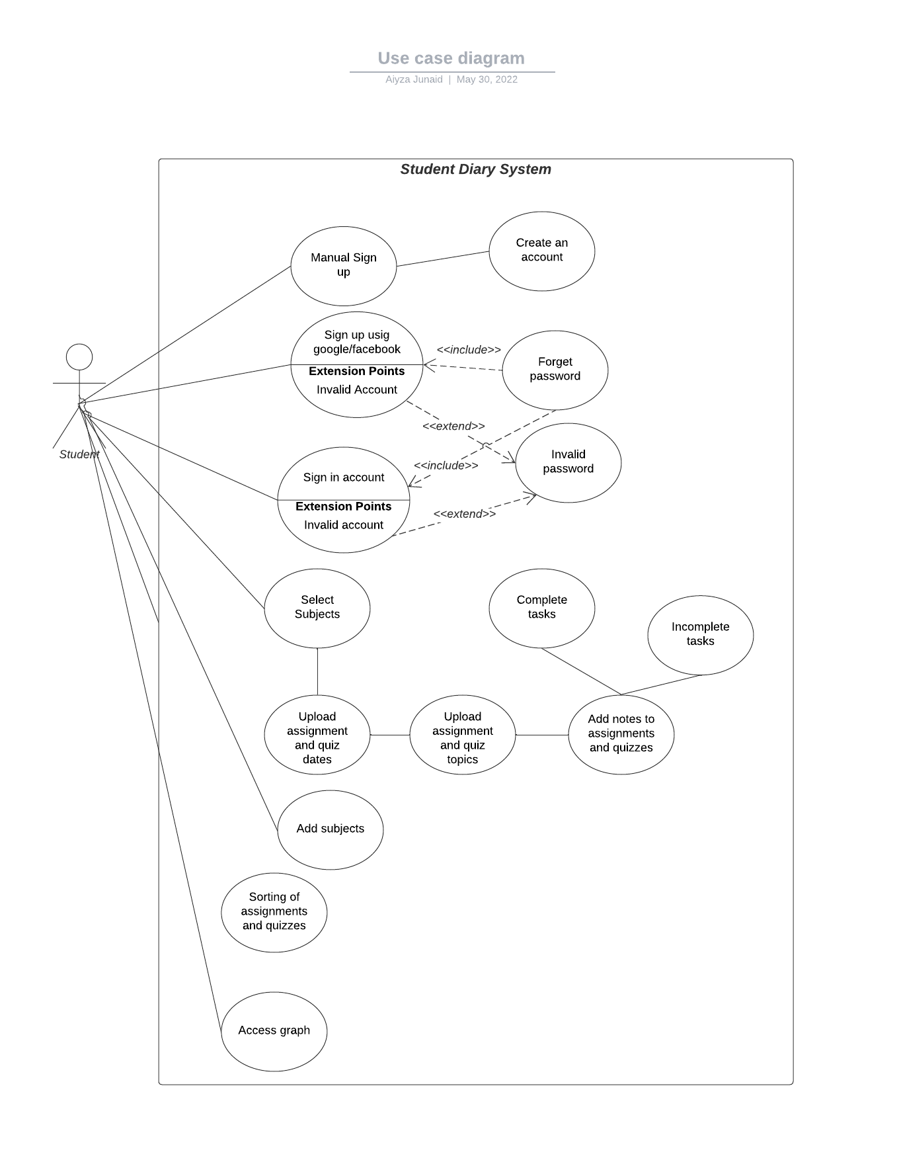

Activity Diagrams:

- Adding Personal Information:

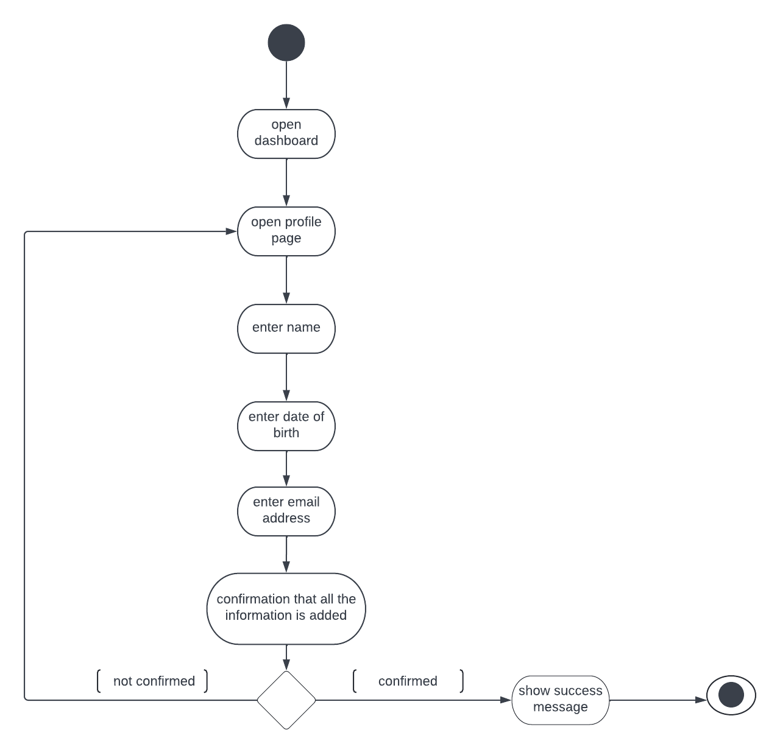

- Adding Course Information:

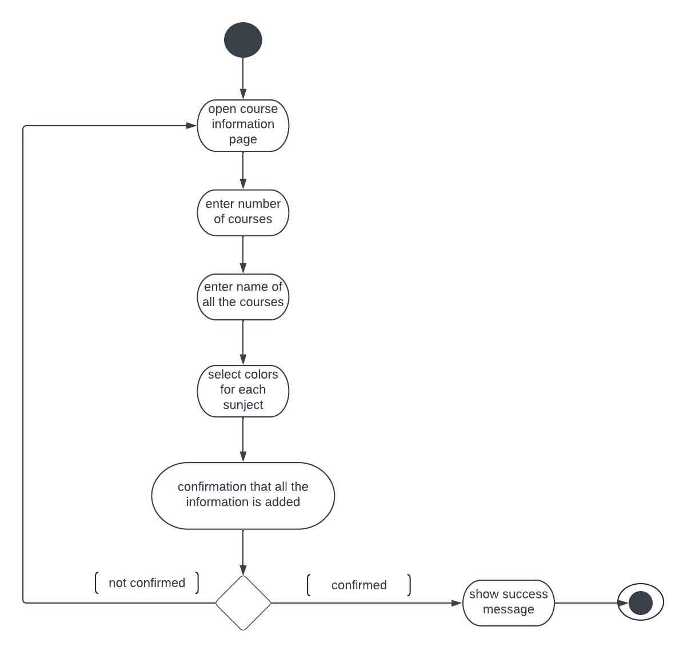

- Adding assignment and quiz dates in calendar:

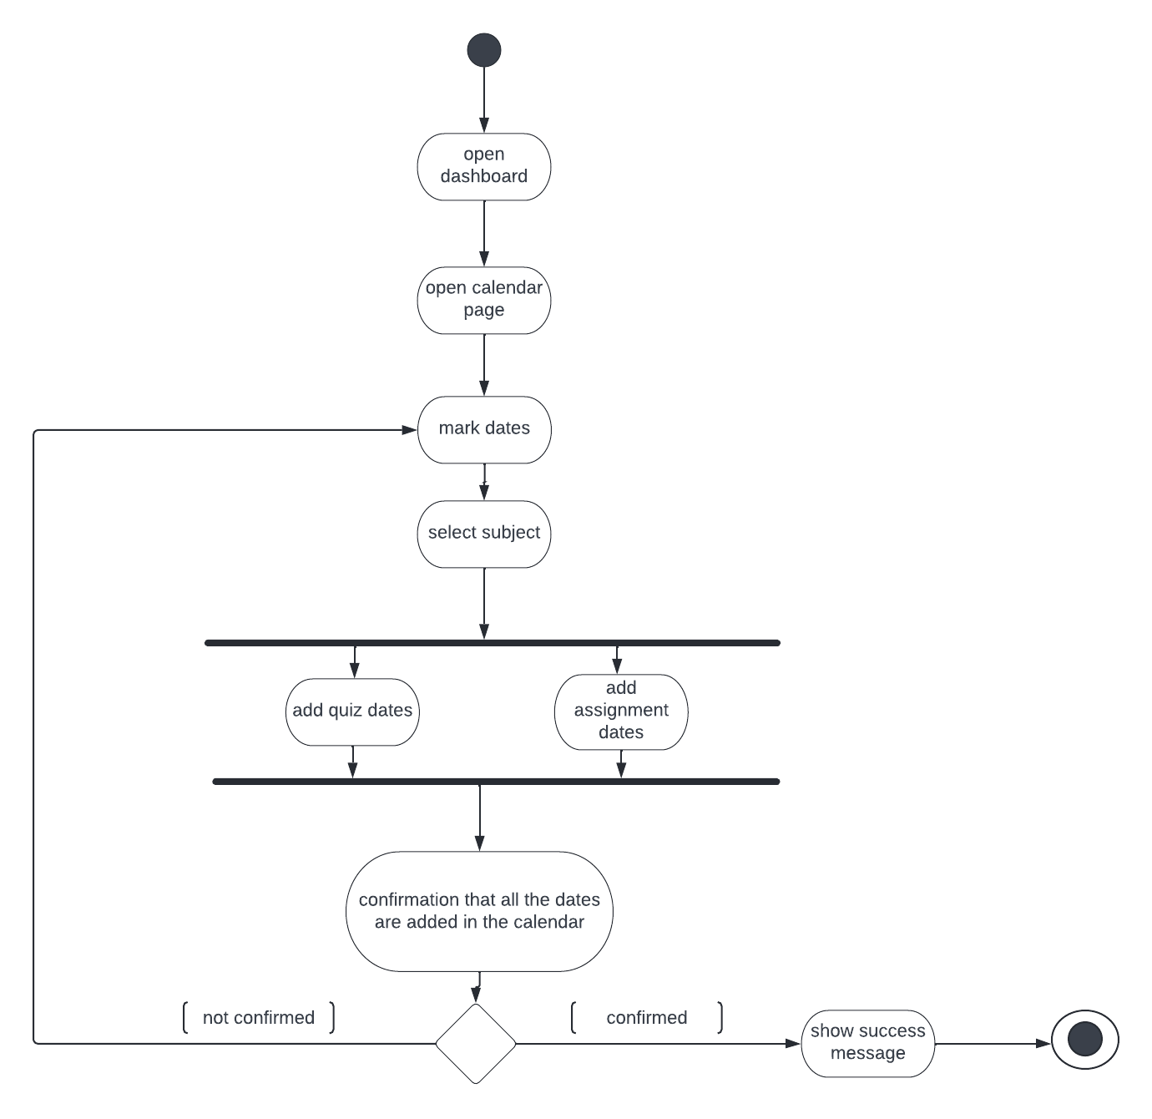

Sequence Diagrams:

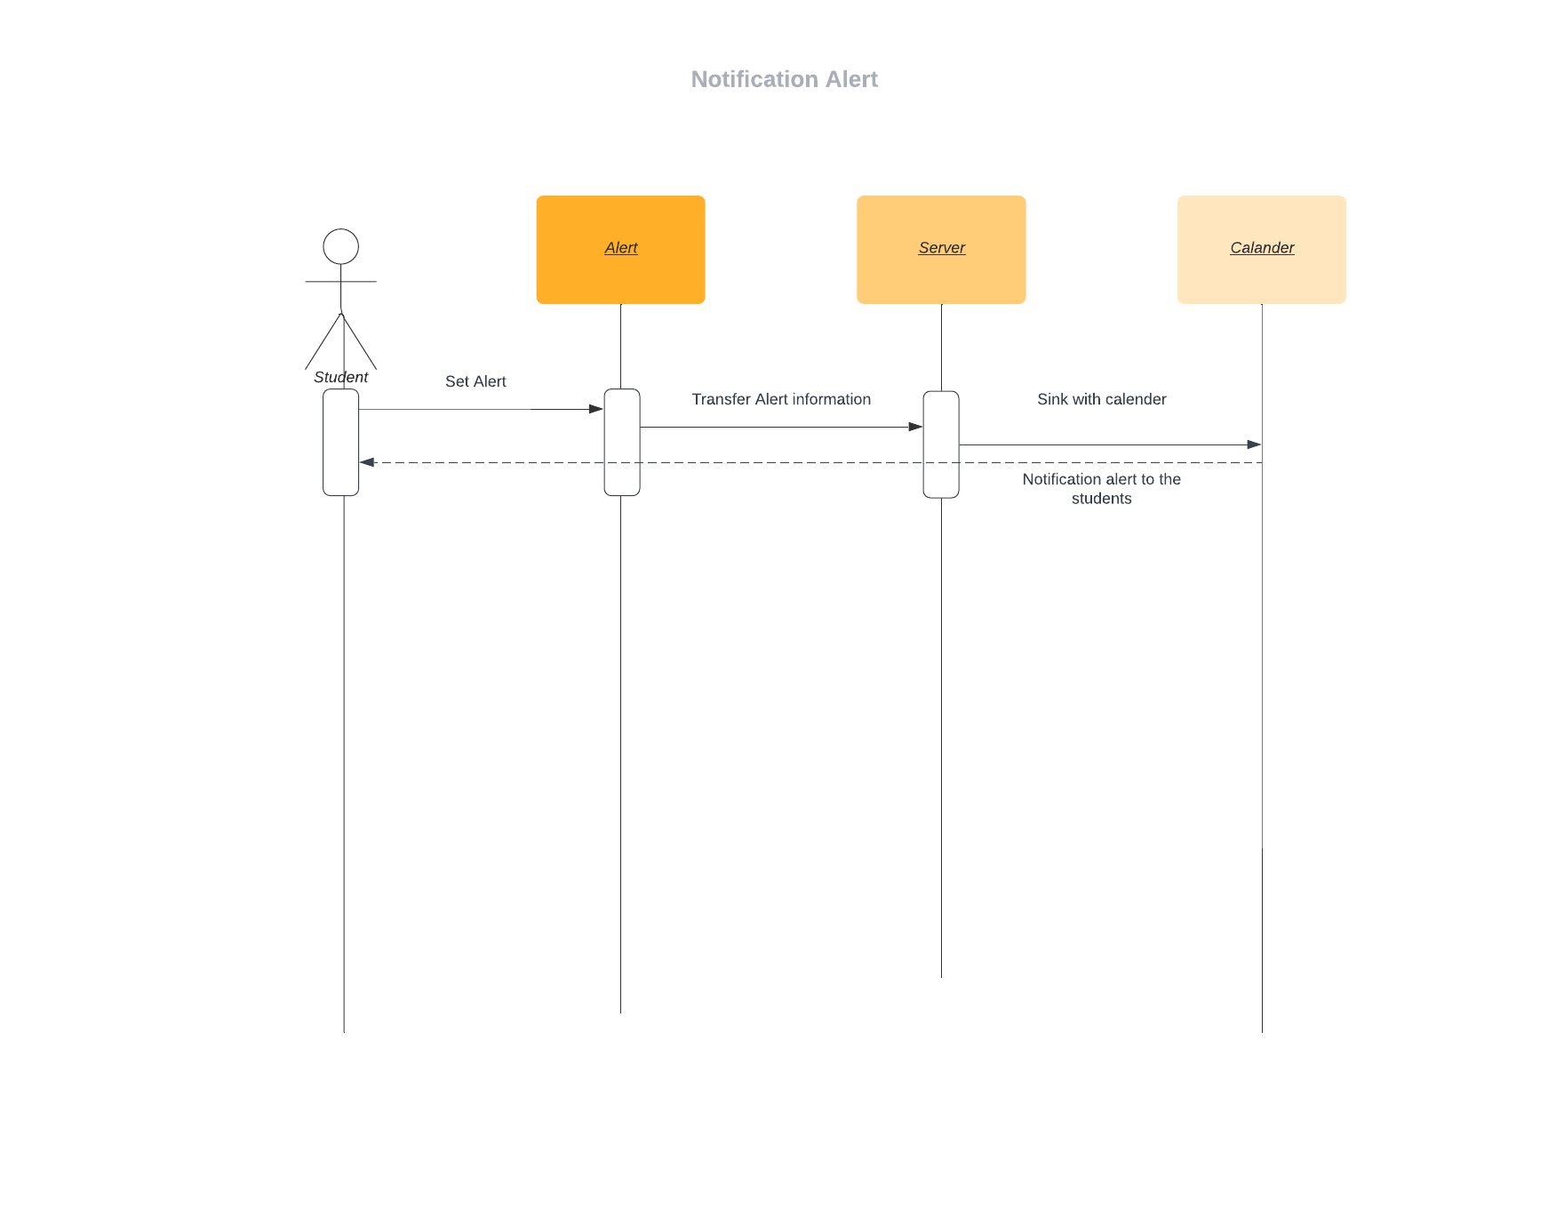

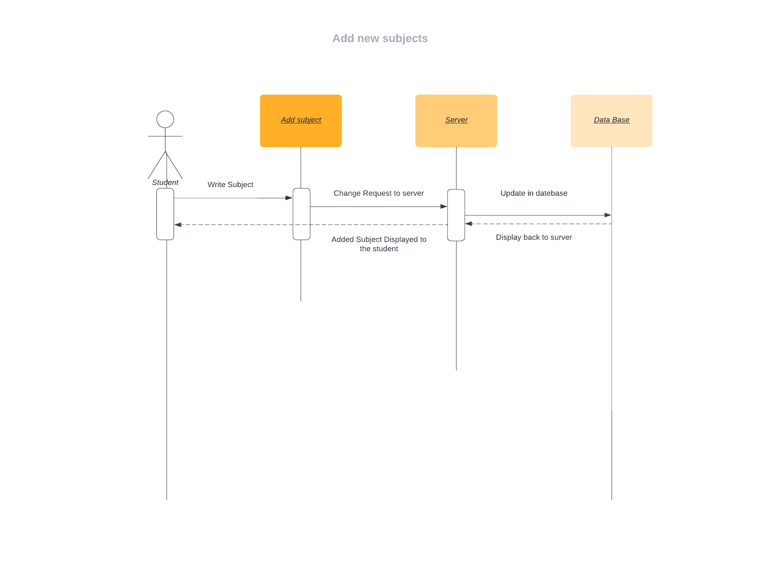

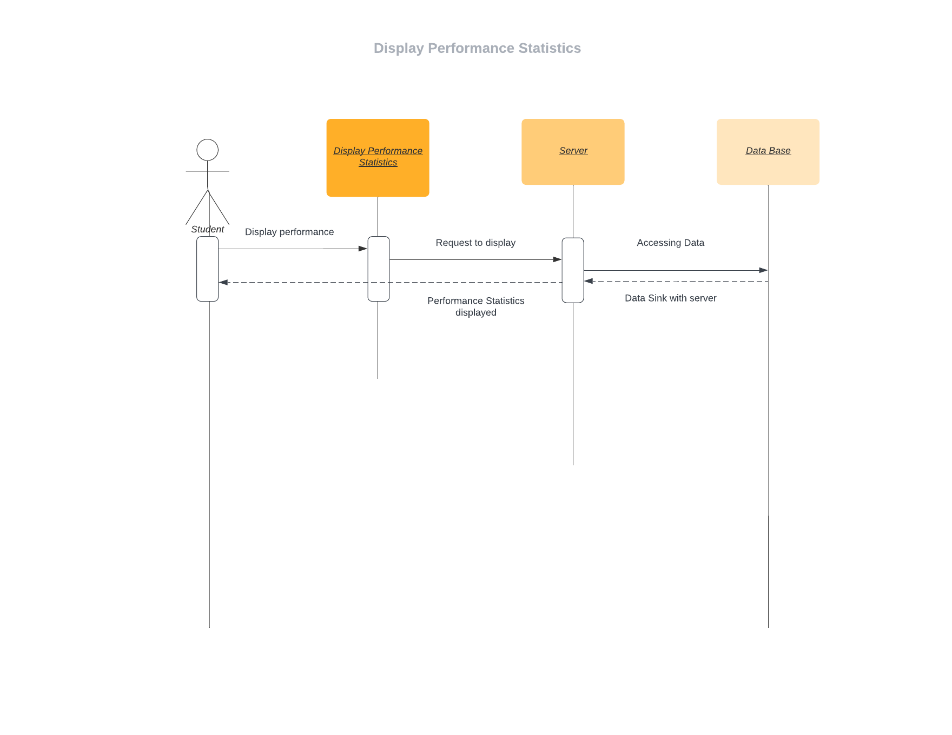

Class Diagram:

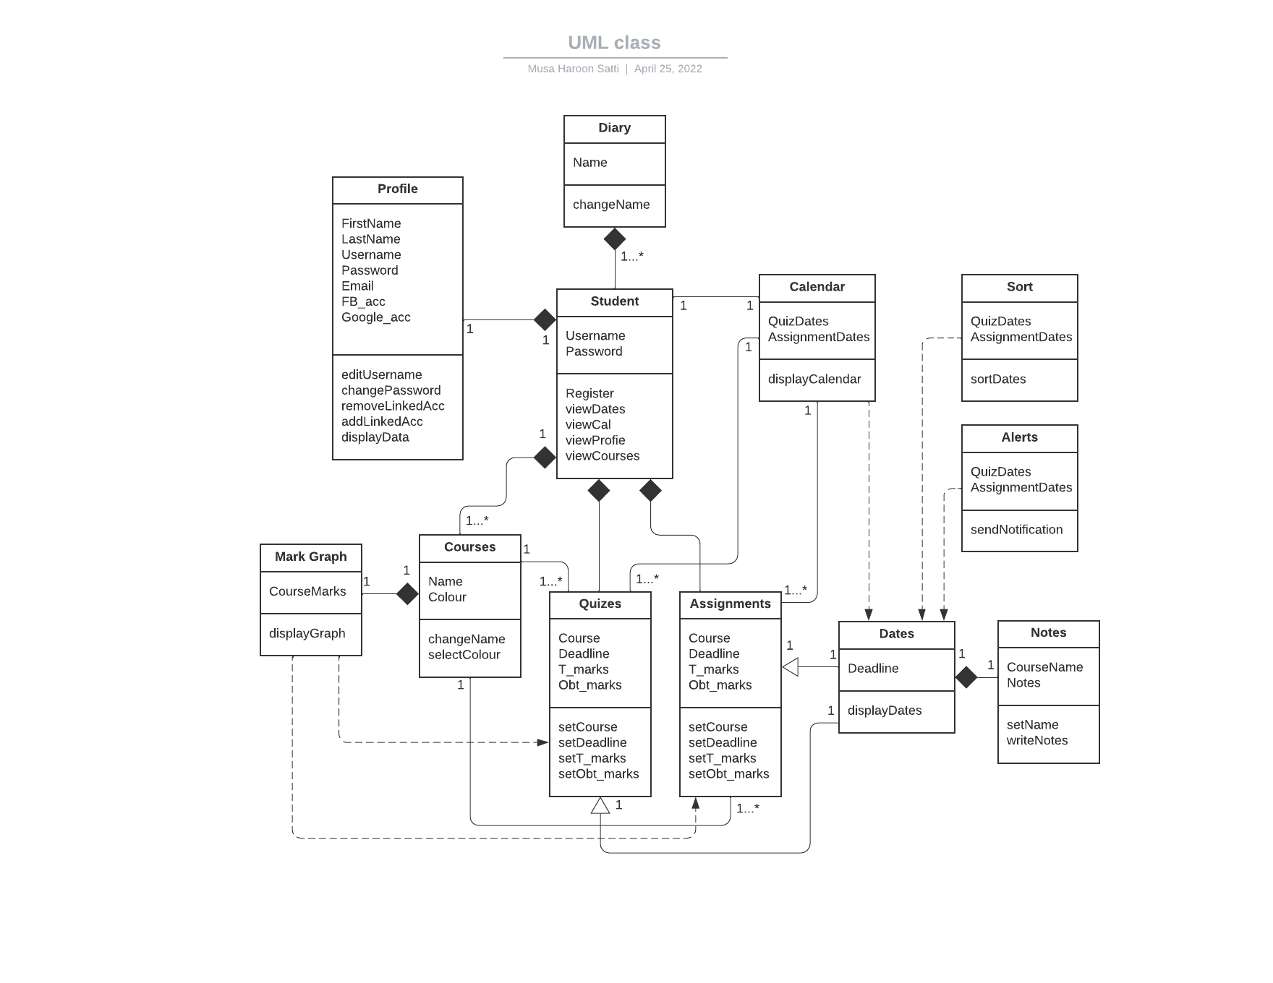

- Architecture:
We have used an event based architecture because we made a scheduling management system that uses a database. Event based architecture is apt for management systems for data integrity. Moreover, this type of architecture supports reusability and evolution of the system. We have used this architecture as it would enable us to use all these properties in our app.
Event Based Architecture:

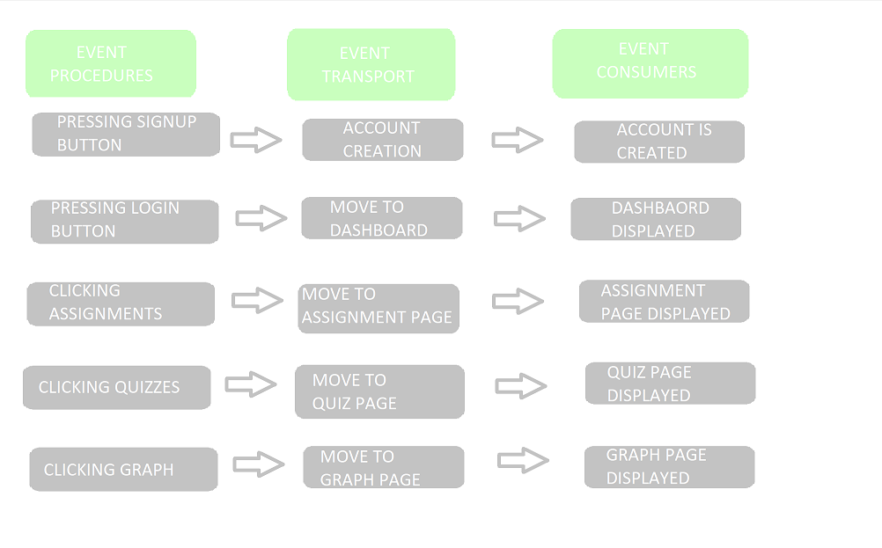

- Implementation:

Signup page

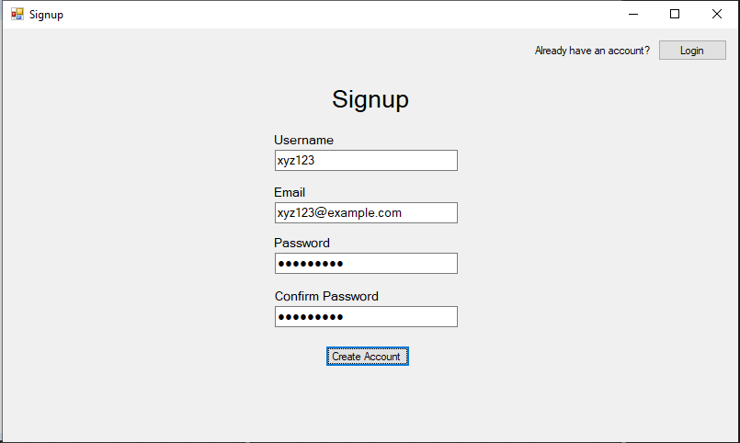

Login Page

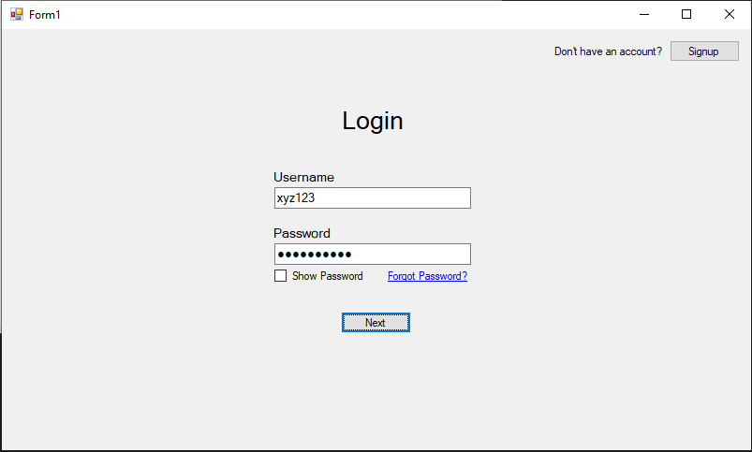

Forget Password

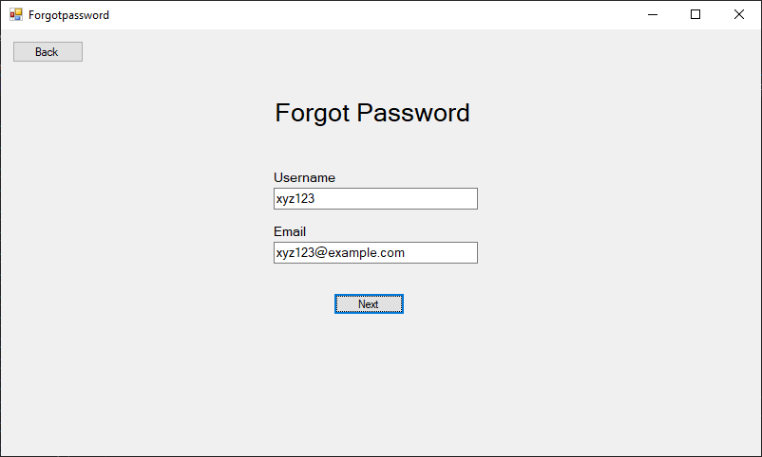

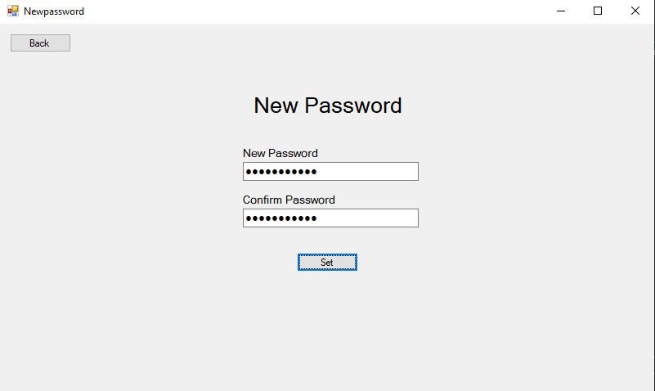

Dashboard

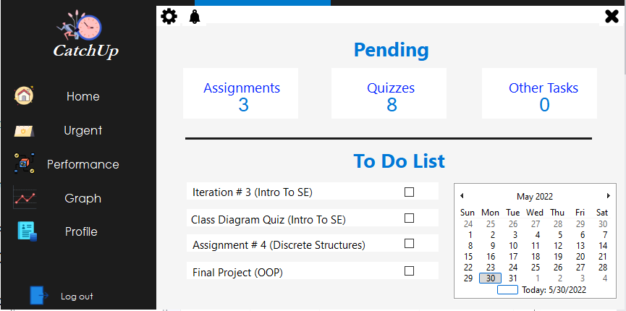

- Burndown Chart of the Project:

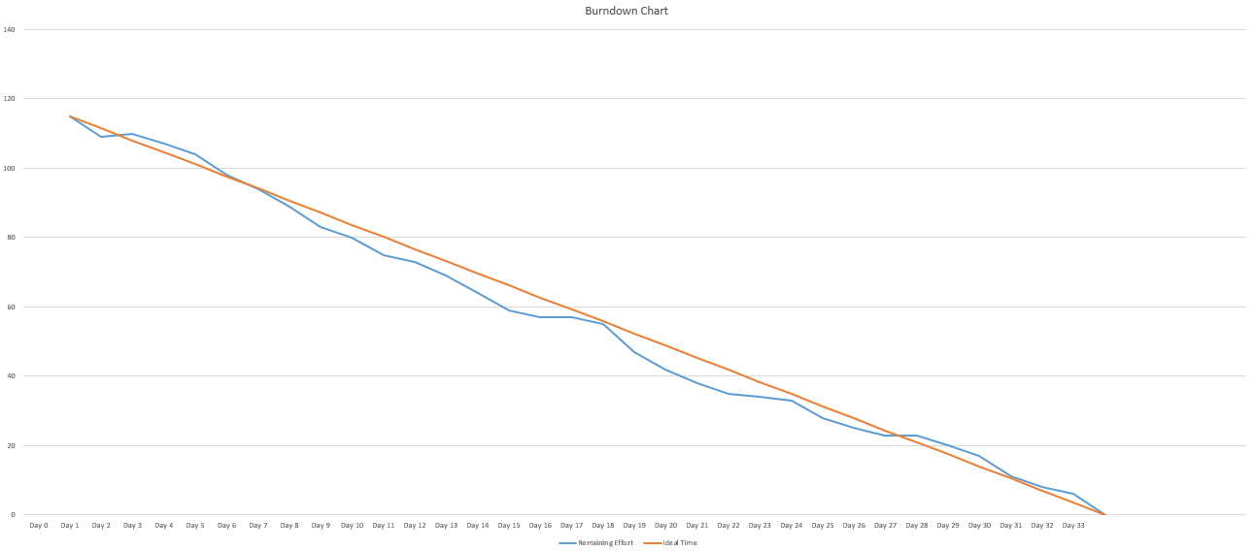

- Scrum Board:

Screenshot 1:

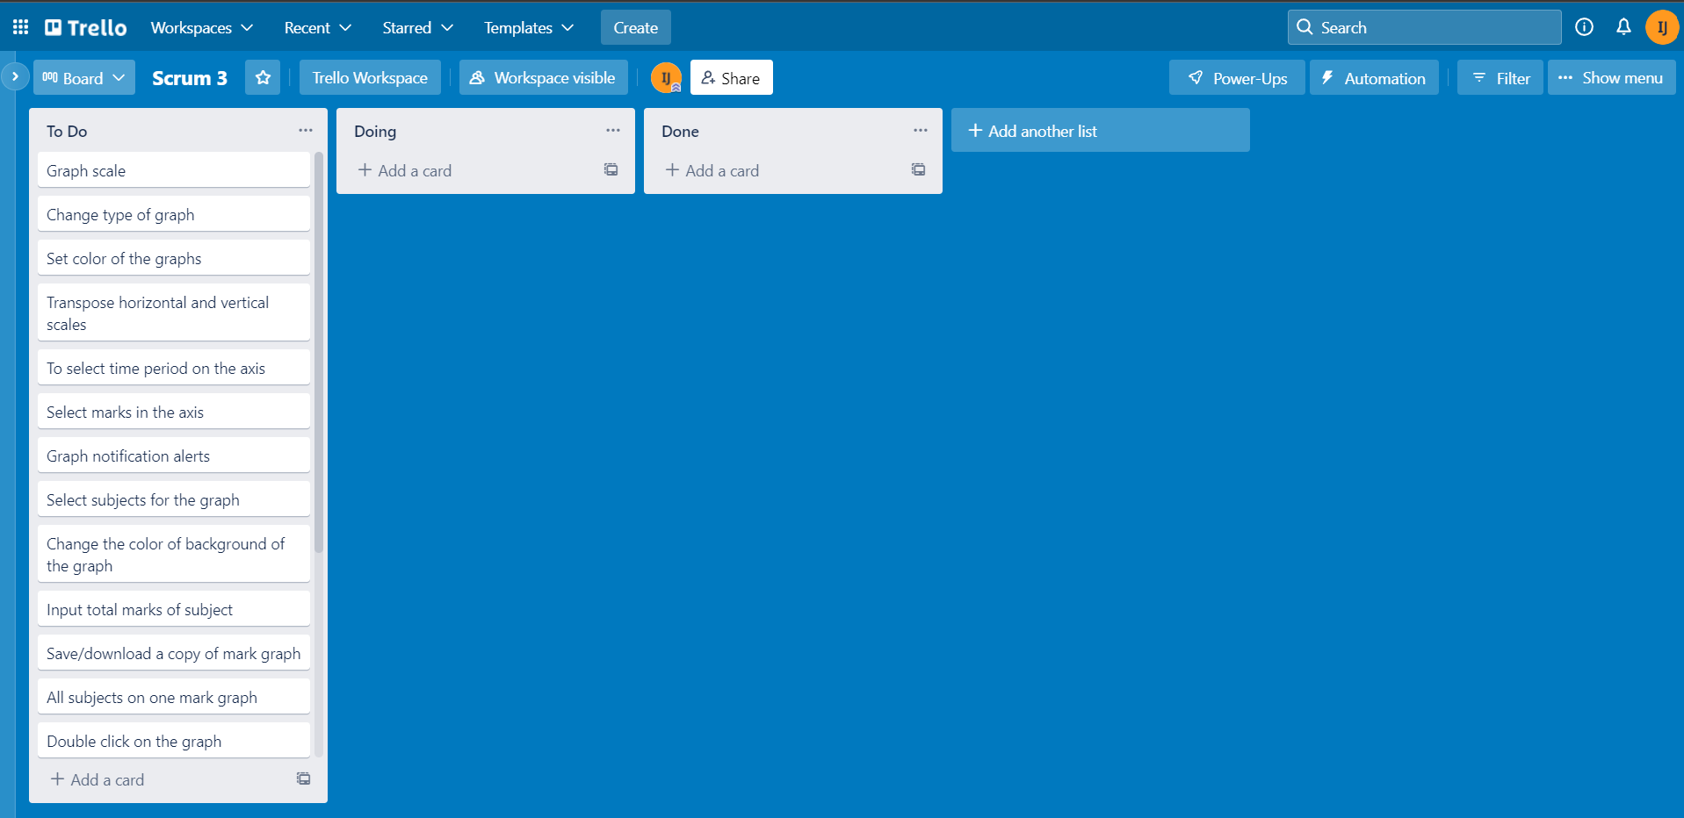

Screenshot 2:

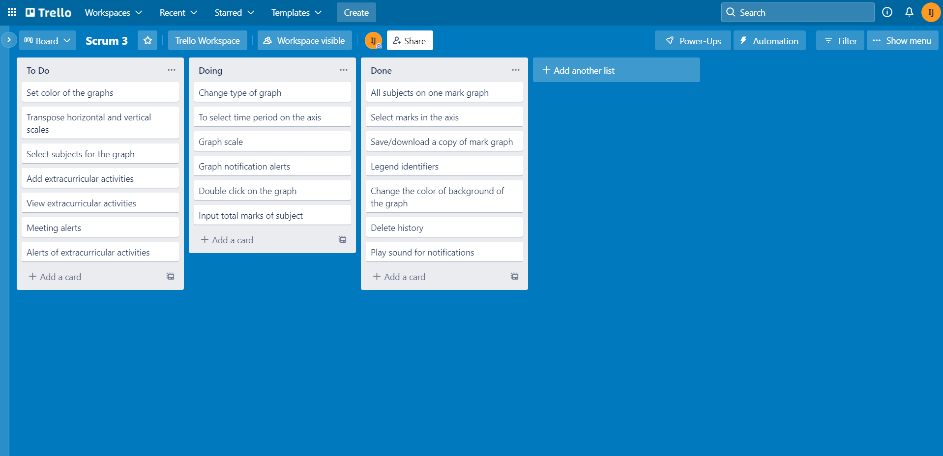

Screenshot 3:

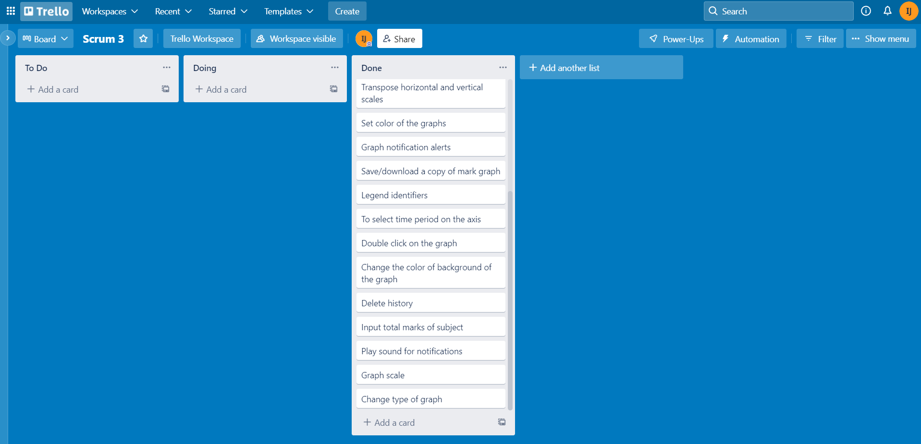

- Boundary Value Analysis:

Boundary Value Analysis of Sign up page:

Test cases for Sign up Page left blank

Test Case ID: TC-01 Test Item: Signup information
Written by: Aiyza Junaid Document Date: 25th May, 2022
Test Type: Manual
Product Name: Student Diary App
Test case description: I want to check to see what will happen if all fields are left unfilled
Operation Procedure:
Open Sign up page
Click create account button
Pre-Conditions: Sign up page opened
Post-Condition: Error message displayed
Inputs data and/or events: none
Expected output data and/or events: Error message “Missing” will be displayed over each field.
Actual output: Error message “Missing” displayed over each field.
Result: Pass
Required test scripts (for auto): NA

Test Case ID: TC-02 Test Item: Signup information
Written by: Aiyza Junaid Document Date: 25th May, 2022
Test Type: Manual
Product Name: Student Diary App
Test case description: I want to check to see what will happen if any one field is left unfilled
Operation Procedure:
Open Sign up page
Click on email textbox
Input “test@gmail.com”
Click password textbox
Input “12345”
Click create account button
Pre-Conditions: Sign up page opened
Post-Condition: Error message displayed
Inputs data and/or events: “test@gmail.com”, “12345”
Expected output data and/or events: Error message “Empty” will be displayed over fields that are empty.
Actual output: Error message “Empty” displayed over each field that is empty.
Result: Pass
Required test scripts (for auto): NA

Test Case ID: TC-03 Test Item: Signup information
Written by: Aiyza Junaid Document Date: 25th May, 2022
Test Type: Manual
Product Name: Student Diary App
Test case description: I want to check to see what will happen if all fields are filled appropriately
Operation Procedure:
Open Sign up page
Click on username textbox
Input “amna”
Click on email textbox
Input “test@gmail.com”
Click password textbox
Input “12345”
Click create account button
Pre-Conditions: Sign up page opened
Post-Condition: Dashboard displayed
Inputs data and/or events: “amna”, “test@gmail.com”, “12345”, “12345”
Expected output data and/or events: Dashboard page displayed
Actual output: Dashboard page displayed
Result: Pass
Required test scripts (for auto): NA

Test Cases for checking range of 3-12 for user name
Test Case ID: TC-04 Test Item: Username field
Written by: Aiyza Junaid Document Date: 25th May, 2022
Test Type: Manual
Product Name: Student Diary App
Test case description: username validation
Operation Procedure:
Open Sign up page
Click on username textbox
Input “al”
Click on email textbox
Input “test@gmail.com”
Click password textbox
Input “12345”
Click on confirm password textbox
Input “12345”
Click create account button
Pre-Conditions: Sign up page opened
Post-Condition: Error message displayed
Inputs data and/or events: “al”, “test@gmail.com”, “12345”, “12345”
Expected output data and/or events: Error message “3-15 characters”
Actual output: Error message “3-15 characters”
Result: pass
Required test scripts (for auto): NA

Test Case ID: TC-05 Test Item: Username field
Written by: Aiyza Junaid Document Date: 25th May, 2022
Test Type: Manual
Product Name: Student Diary App
Test case description: username validation
Operation Procedure:
Open Sign up page
Click on username textbox
Input “ali”
Click on email textbox
Input “test@gmail.com”
Click password textbox
Input “12345”
Click on confirm password textbox
Input “12345”
Click create account button
Pre-Conditions: Sign up page opened
Post-Condition: Dashboard page opened
Inputs data and/or events: “ali”, “test@gmail.com”, “12345”, “12345”
Expected output data and/or events: Dashboard page displayed
Actual output: Dashboard page displayed
Result: pass
Required test scripts (for auto): NA

Test Case ID: TC-06 Test Item: Username field
Written by: Aiyza Junaid Document Date: 25th May, 2022
Test Type: Manual
Product Name: Student Diary App
Test case description: username validation
Operation Procedure:
Open Sign up page
Click on username textbox
Input “saim”
Click on email textbox
Input “test@gmail.com”
Click password textbox
Input “12345”
Click on confirm password textbox
Input “12345”
Click create account button
Pre-Conditions: Sign up page opened
Post-Condition: Dashboard page opened
Inputs data and/or events: “saim”, “test@gmail.com”, “12345” , “12345”
Expected output data and/or events: Dashboard displayed
Actual output: Dashboard displayed
Result: pass
Required test scripts (for auto): NA

Test Case ID: TC-07 Test Item: Username field
Written by: Aiyza Junaid Document Date: 25th May, 2022
Test Type: Manual
Product Name: Student Diary App
Test case description: username validation
Operation Procedure:
Open Sign up page
Click on username textbox
Input “huzaifa_ali”
Click on email textbox
Input “test@gmail.com”
Click password textbox
Input “12345”
Click on confirm password textbox
Input “12345”
Click create account button
Pre-Conditions: Sign up page opened
Post-Condition: Dashboard page opened
Inputs data and/or events: “huzaifa_quresh”, “test@gmail.com”, “12345”, “12345”
Expected output data and/or events: Dashboard page displayed
Actual output: Dashboard page displayed
Result: pass
Required test scripts (for auto): NA

Test Case ID: TC-08 Test Item: Username field
Written by: Aiyza Junaid Document Date: 25th May, 2022
Test Type: Manual
Product Name: Student Diary App
Test case description: username validation
Operation Procedure:
Open Sign up page
Click on username textbox
Input “huzaifa_saim”
Click on email textbox
Input “test@gmail.com”
Click password textbox
Input “12345”
Click on confirm password textbox
Input “12345”
Click create account button
Pre-Conditions: Sign up page opened
Post-Condition: Dashboard page opened
Inputs data and/or events: “huzaifa_qureshi”, “test@gmail.com”, “12345”
Expected output data and/or events: Dashboard page displayed
Actual output: Dashboard page displayed
Result: pass
Required test scripts (for auto): NA

Test Case ID: TC-09 Test Item: Username field
Written by: Aiyza Junaid Document Date: 25th May, 2022
Test Type: Manual
Product Name: Student Diary App
Test case description: username validation
Operation Procedure:
Open Sign up page
Click on username textbox
Input “huzafa_quresh”
Click on email textbox
Input “test@gmail.com”
Click password textbox
Input “12345”
Click on confirm password textbox
Input “12345”
Click create account button
Pre-Conditions: Sign up page opened
Post-Condition: Error message displayed
Inputs data and/or events: “huzafa_quresh”, “test@gmail.com”, “12345”, “12345”
Expected output data and/or events: Error message “ 3-12 characters”
Actual output: Error message “ 3-12 characters”
Result: pass
Required test scripts (for auto): NA

Test Cases for checking special characters in user name
Test Case ID: TC-10 Test Item: Username field
Written by: Aiyza Junaid Document Date: 25th May, 2022
Test Type: Manual
Product Name: Student Diary App
Test case description: username validation
Operation Procedure:
Open Sign up page
Click on username textbox
Input “_huzaifa”
Click on email textbox
Input “test@gmail.com”
Click password textbox
Input “12345”
Click on confirm password textbox
Input “12345”
Click create account button
Pre-Conditions: Sign up page opened
Post-Condition: Error message displayed
Inputs data and/or events: “_huzaifa”, “test@gmail.com”, “12345”, “12345”
Expected output data and/or events: Error message “Invalid”
Required test scripts (for auto): NA
Test Case ID: TC-11 Test Item: Username field
Written by: Aiyza Junaid Document Date: 25th May, 2022
Test Type: Manual
Product Name: Student Diary App
Test case description: username validation
Operation Procedure:
Open Sign up page
Click on username textbox
Input “amna_123”
Click on email textbox
Input “test@gmail.com”
Click password textbox
Input “12345”
Click on confirm password textbox
Input “12345”
Click create account button
Pre-Conditions: Sign up page opened
Post-Condition: Dashboard page opened
Inputs data and/or events: “amna_123”, “test@gmail.com”, “12345”, “12345”
Expected output data and/or events: Dashboard page displayed
Actual output: Dashboard page displayed
Result: pass
Required test scripts (for auto): NA

Test Case ID: TC-12 Test Item: Username field
Written by: Aiyza Junaid Document Date: 25th May, 2022
Test Type: Manual
Product Name: Student Diary App
Test case description: username validation
Operation Procedure:
Open Sign up page
Click on username textbox
Input “amna123_”
Click on email textbox
Input “test@gmail.com”
Click password textbox
Input “12345”
Click on confirm password textbox
Input “12345”
Click create account button
Pre-Conditions: Sign up page opened
Post-Condition: Dashboard page opened
Inputs data and/or events: “amna_123”, “test@gmail.com”, “12345”, “12345”
Expected output data and/or events: Dashboard page displayed
Actual output: Dashboard page displayed
Result: pass
Required test scripts (for auto): NA

Test Case ID: TC-13 Test Item: Username field
Written by: Aiyza Junaid Document Date: 25th May, 2022
Test Type: Manual
Product Name: Student Diary App
Test case description: username validation
Operation Procedure:
Open Sign up page
Click on username textbox
Input “huzaifa*ali”
Click on email textbox
Input “test@gmail.com”
Click password textbox
Input “12345”
Click on confirm password textbox
Input “12345”
Click create account button
Pre-Conditions: Sign up page opened
Post-Condition: Error message displayed
Inputs data and/or events: “huzaifa*ali”, “test@gmail.com”, “12345”, “12345”
Expected output data and/or events: Error message “Invalid”
Actual output: Error message “Invalid”
Result: pass
Required test scripts (for auto): NA

Test Cases for checking range of 3-8 characters in password
Test Case ID: TC-14 Test Item: Password field
Written by: Aiyza Junaid Document Date: 25th May, 2022
Test Type: Manual
Product Name: Student Diary App
Test case description: password validation
Operation Procedure:
Open Sign up page
Click on username textbox
Input “ali”
Click on email textbox
Input “test@gmail.com”
Click password textbox
Input “12”
Click on confirm password textbox
Input “12”
Click create account button
Pre-Conditions: Sign up page opened
Post-Condition: Error message displayed
Inputs data and/or events: “ali”, “test@gmail.com”, “12”, “12”
Expected output data and/or events: Error message “ 3-8 characters”
Actual output: Error message “ 3-8 characters”
Result: pass
Required test scripts (for auto): NA

Test Case ID: TC-15 Test Item: Password field
Written by: Aiyza Junaid Document Date: 25th May, 2022
Test Type: Manual
Product Name: Student Diary App
Test case description: password validation
Operation Procedure:
Open Sign up page
Click on username textbox
Input “ali”
Click on email textbox
Input “test@gmail.com”
Click password textbox
Input “123”
Click on confirm password textbox
Input “123”
Click create account button
Pre-Conditions: Sign up page opened
Post-Condition: Dashboard page opened
Inputs data and/or events: “ali”, “test@gmail.com”, “123”, “123”
Expected output data and/or events: Dashboard page displayed
Actual output: Dashboard page displayed
Result: pass
Required test scripts (for auto): NA

Test Case ID: TC-16 Test Item: Password field
Written by: Aiyza Junaid Document Date: 25th May, 2022
Test Type: Manual
Product Name: Student Diary App
Test case description: password validation
Operation Procedure:
Open Sign up page
Click on username textbox
Input “saim”
Click on email textbox
Input “test@gmail.com”
Click password textbox
Input “1234”
Click on confirm password textbox
Input “1234”
Click create account button
Pre-Conditions: Sign up page opened
Post-Condition: Dashboard page opened
Inputs data and/or events: “saim”, “test@gmail.com”, “1234”, “1234”
Expected output data and/or events: Dashboard page displayed
Actual output: Dashboard page displayed
Result: pass
Required test scripts (for auto): NA

Test Case ID: TC-17 Test Item: Password field
Written by: Aiyza Junaid Document Date: 25th May, 2022
Test Type: Manual
Product Name: Student Diary App
Test case description: password validation
Operation Procedure:
Open Sign up page
Click on username textbox
Input “Ali”
Click on email textbox
Input “test@gmail.com”
Click password textbox
Input “1234567”
Click on confirm password textbox
Input “123457”
Click create account button
Pre-Conditions: Sign up page opened
Post-Condition: Dashboard page opened
Inputs data and/or events: “Ali”, “test@gmail.com”, “1234567”, “1234567”
Expected output data and/or events: Dashboard page displayed
Actual output: Dashboard page displayed
Result: pass
Required test scripts (for auto): NA

Test Case ID: TC-18 Test Item: Password field
Written by: Aiyza Junaid Document Date: 25th May, 2022
Test Type: Manual
Product Name: Student Diary App
Test case description: password validation
Operation Procedure:
Open Sign up page
Click on username textbox
Input “Ali”
Click on email textbox
Input “test@gmail.com”
Click password textbox
Input “12345678”
Click on confirm password textbox
Input “12345678”
Click create account button
Pre-Conditions: Sign up page opened
Post-Condition: Dashboard page opened
Inputs data and/or events: “ali”, “test@gmail.com”, “12345678”, “12345678”
Expected output data and/or events: Dashboard page displayed
Actual output: Dashboard page displayed
Result: pass
Required test scripts (for auto): NA

Test Case ID: TC-19 Test Item: Password field
Written by: Aiyza Junaid Document Date: 25th May, 2022
Test Type: Manual
Product Name: Student Diary App
Test case description: password validation
Operation Procedure:
Open Sign up page
Click on username textbox
Input “Ali”
Click on email textbox
Input “test@gmail.com”
Click password textbox
Input “123456789”
Click on confirm password textbox
Input “12345789”
Click create account button
Pre-Conditions: Sign up page opened
Post-Condition: Error message displayed
Inputs data and/or events: “Ali”, “test@gmail.com”, “123456789”, “123456789”
Expected output data and/or events: Error message “3-8 characters”
Actual output: Error message “3-8 characters”
Result: pass
Required test scripts (for auto): NA

Test Cases for checking special characters in password
Test Case ID: TC-20 Test Item: Password field
Written by: Aiyza Junaid Document Date: 25th May, 2022
Test Type: Manual
Product Name: Student Diary App
Test case description: password validation
Operation Procedure:
Open Sign up page
Click on username textbox
Input “Ali”
Click on email textbox
Input “test@gmail.com”
Click password textbox
Input “ 123*45”
Click on confirm password textbox
Input “123*45”
Click create account button
Pre-Conditions: Sign up page opened
Post-Condition: Dashboard page opened
Inputs data and/or events: “Ali”, “test@gmail.com”, “ 123*45”, “123*45”
Expected output data and/or events: Dashboard page displayed
Actual output: Dashboard page displayed
Result: pass
Required test scripts (for auto): NA

Test Case ID: TC-21 Test Item: Password field
Written by: Aiyza Junaid Document Date: 25th May, 2022
Test Type: Manual
Product Name: Student Diary App
Test case description: password validation
Operation Procedure:
Open Sign up page
Click on username textbox
Input “Ali”
Click on email textbox
Input “test@gmail.com”
Click password textbox
Input “ 123 45”
Click on confirm password textbox
Input “123 45”
Click create account button
Pre-Conditions: Sign up page opened
Post-Condition: Dashboard page opened
Inputs data and/or events: “Ali”, “test@gmail.com”, “ 123 45”, “123 45”
Expected output data and/or events: Dashboard page displayed
Actual output: Dashboard page displayed
Result: pass
Required test scripts (for auto): NA

Test Case ID: TC-22 Test Item: Password field
Written by: Aiyza Junaid Document Date: 25th May, 2022
Test Type: Manual
Product Name: Student Diary App
Test case description: password validation
Operation Procedure:
Open Sign up page
Click on username textbox
Input “amna_123”
Click on email textbox
Input “test@gmail.com”
Click password textbox
Input “ 12345”
Click on confirm password textbox
Input “ 12345”
Click create account button
Pre-Conditions: Sign up page opened
Post-Condition: Error message displayed
Inputs data and/or events: “amna_123”, “test@gmail.com”, “ 12345”,
“ 12345”
Expected output data and/or events: Error message “Invalid”
Actual output: Error message “Invalid”
Result: pass
Required test scripts (for auto): NA

Test Case ID: TC-23 Test Item: Password field
Written by: Aiyza Junaid Document Date: 25th May, 2022
Test Type: Manual
Product Name: Student Diary App
Test case description: password validation
Operation Procedure:
Open Sign up page
Click on username textbox
Input “amna_123”
Click on email textbox
Input “test@gmail.com”
Click password textbox
Input “a12345 ”
Click on confirm password textbox
Input “a12345 ”
Click create account button
Pre-Conditions: Sign up page opened
Post-Condition: Error message displayed
Inputs data and/or events: “amna_123”, “test@gmail.com”, “a12345 ”, “a12345 ”
Expected output data and/or events: Error message “Invalid”
Actual output: Error message “Invalid”
Result: pass
Required test scripts (for auto): NA

Test Cases for checking confirm password
Test Case ID: TC-24 Test Item: Confirm password field
Written by: Aiyza Junaid Document Date: 25th May, 2022
Test Type: Manual
Product Name: Student Diary App
Test case description: confirm password validation
Operation Procedure:
Open Sign up page
Click on username textbox
Input “Ali”
Click on email textbox
Input “test@gmail.com”
Click password textbox
Input “ 123 45”
Click on confirm password textbox
Input “123 45”
Click create account button
Pre-Conditions: Sign up page opened
Post-Condition: Dashboard page opened
Inputs data and/or events: “Ali”, “test@gmail.com”, “ 123 45”, “123 45”
Expected output data and/or events: Dashboard page displayed
Actual output: Dashboard page displayed
Result: pass
Required test scripts (for auto): NA

Test Case ID: TC-25 Test Item: Confirm Password field
Written by: Aiyza Junaid Document Date: 25th May, 2022
Test Type: Manual
Product Name: Student Diary App
Test case description: confirm password validation
Operation Procedure:
Open Sign up page
Click on username textbox
Input “amna_123”
Click on email textbox
Input “test@gmail.com”
Click password textbox
Input “a12345 ”
Click on confirm password textbox
Input “12345 ”
Click create account button
Pre-Conditions: Sign up page opened
Post-Condition: Error message displayed
Inputs data and/or events: “amna_123”, “test@gmail.com”, “a12345 ”, “12345 ”
Expected output data and/or events: Error message “Invalid”
Actual output: Error message “Invalid”
Result: pass
Required test scripts (for auto): NA

Test cases for checking minimum 7 characters in email
Test Case ID: TC-26 Test Item: Email field
Written by: Aiyza Junaid Document Date: 25th May, 2022
Test Type: Manual
Product Name: Student Diary App
Test case description: email validation
Operation Procedure:
Open Sign up page
Click on username textbox
Input “amna_123”
Click on email textbox
Input “@l.com”
Click password textbox
Input “12345”
Click on confirm password textbox
Input “12345 ”
Click create account button
Pre-Conditions: Sign up page opened
Post-Condition: Error message displayed
Inputs data and/or events: “amna_123”, “@l.cm”, “12345”, “12345”
Expected output data and/or events: Error message “Invalid”
Actual output: Error message “Invalid”
Result: pass
Required test scripts (for auto): NA

Test Case ID: TC-27 Test Item: Email field
Written by: Aiyza Junaid Document Date: 25th May, 2022
Test Type: Manual
Product Name: Student Diary App
Test case description: email validation
Operation Procedure:
Open Sign up page
Click on username textbox
Input “amna_123”
Click on email textbox
Input “t@l.com”
Click password textbox
Input “12345”
Click on confirm password textbox
Input “12345 ”
Click create account button
Pre-Conditions: Sign up page opened
Post-Condition: Dashboard page opened
Inputs data and/or events: “amna_123”, “t@l.cm”, “12345”, “12345”
Expected output data and/or events: Dashboard page displayed
Actual output: Dashboard page displayed
Result: pass
Required test scripts (for auto): NA

Test Case ID: TC-28 Test Item: Email field
Written by: Aiyza Junaid Document Date: 25th May, 2022
Test Type: Manual
Product Name: Student Diary App
Test case description: email validation
Operation Procedure:
Open Sign up page
Click on username textbox
Input “amna_123”
Click on email textbox
Input “tu@l.com”
Click password textbox
Input “12345”
Click on confirm password textbox
Input “12345 ”
Click create account button
Pre-Conditions: Sign up page opened
Post-Condition: Dashboard page opened
Inputs data and/or events: “amna_123”, “tu@l.cm”, “12345”, “12345”
Expected output data and/or events: Dashboard page displayed
Actual output: Dashboard page displayed
Result: pass
Required test scripts (for auto): NA

Test case for .com in email
Test Case ID: TC-29 Test Item: Email field
Written by: Aiyza Junaid Document Date: 25th May, 2022
Test Type: Manual
Product Name: Student Diary App
Test case description: email validation
Operation Procedure:
Open Sign up page
Click on username textbox
Input “amna_123”
Click on email textbox
Input “a@gail.m”
Click password textbox
Input “a123_45”
Click on confirm password textbox
Input “a123_45 ”
Click create account button
Pre-Conditions: Sign up page opened
Post-Condition: Error message displayed
Inputs data and/or events: “amna_123”, “a@gail.m””, “a123_45”, “a123_45”
Expected output data and/or events: Error message “Invalid”
Actual output: Error message “Invalid”
Result: pass
Required test scripts (for auto): NA

Test case for @ in email
Test Case ID: TC-30 Test Item: Email field
Written by: Aiyza Junaid Document Date: 25th May, 2022
Test Type: Manual
Product Name: Student Diary App
Test case description: email validation
Operation Procedure:
Open Sign up page
Click on username textbox
Input “amna_123”
Click on email textbox
Input “a@.com”
Click password textbox
Input “a123_45”
Click on confirm password textbox
Input “a123_45 ”
Click create account button
Pre-Conditions: Sign up page opened
Post-Condition: Error message displayed
Inputs data and/or events: “amna_123”, “a@.com”, “a123_45”, “a123_45”
Expected output data and/or events: Error message “Invalid”
Actual output: Error message “Invalid”
Result: pass
Required test scripts (for auto): NA

Test Case ID: TC-31 Test Item: Email field
Written by: Aiyza Junaid Document Date: 25th May, 2022
Test Type: Manual
Product Name: Student Diary App
Test case description: email validation
Operation Procedure:
Open Sign up page
Click on username textbox
Input “amna_123”
Click on email textbox
Input “@a.com”
Click password textbox
Input “a123_45”
Click on confirm password textbox
Input “a123_45 ”
Click create account button
Pre-Conditions: Sign up page opened
Post-Condition: Error message displayed
Inputs data and/or events: “amna_123”, @a.com”, “a123_45”, “a123_45”
Expected output data and/or events: Error message “Invalid”
Actual output: Error message “Invalid”
Result: pass
Required test scripts (for auto): NA

Test Case ID: TC-32 Test Item: Email field
Written by: Aiyza Junaid Document Date: 25th May, 2022
Test Type: Manual
Product Name: Student Diary App
Test case description: email validation
Operation Procedure:
Open Sign up page
Click on username textbox
Input “amna_123”
Click on email textbox
Input “aiyza_123@gmail.com”
Click password textbox
Input “12345”
Click on confirm password textbox
Input “12345 ”
Click create account button
Pre-Conditions: Sign up page opened
Post-Condition: Dashboard page opened
Inputs data and/or events: “amna_123”, “aiyza_123@gmail.com”, “12345”, “12345”
Expected output data and/or events: Dashboard page displayed
Actual output: Dashboard page displayed
Result: pass
Required test scripts (for auto): NA

Boundary Value Analysis of Login page:

Test cases for Login Page left blank/filled
Test Case ID: TC-33 Test Item: Login information
Written by: Aiyza Junaid Document Date: 25th May, 2022
Test Type: Manual
Product Name: Student Diary App
Test case description: I want to check to see what will happen if all fields are left unfilled
Operation Procedure:
Open Login page
Click next
Pre-Conditions: Lign up page opened
Post-Condition: Error message displayed
Inputs data and/or events: none
Expected output data and/or events: Error message “Empty” will be displayed
Actual output: Error message “Empty” will be displayed
Result: pass
Required test scripts (for auto): NA

Test Case ID: TC-34 Test Item: Login information
Written by: Aiyza Junaid Document Date: 25th May, 2022
Test Type: Manual
Product Name: Student Diary App
Test case description: I want to check to see what will happen if all fields are filled appropriately
Operation Procedure:
Open login page
Click on username textbox
Input “amna”
Click password textbox
Input “12345”
Click next
Pre-Conditions: Login page opened
Post-Condition: Dashboard page opened
Inputs data and/or events: “amna”, “12345”
Expected output data and/or events: Dashboard page displayed
Actual output: Dashboard page displayed
Result: pass
Required test scripts (for auto): NA

Test Cases for checking range of 3-12 for user name

Test Case ID: TC-35 Test Item: Username field
Written by: Aiyza Junaid Document Date: 25th May, 2022
Test Type: Manual
Product Name: Student Diary App
Test case description: username validation
Operation Procedure:
Open Login page
Click on username textbox
Input “al”
Click password textbox
Input “12345”
Click next
Pre-Conditions: Login page opened
Post-Condition: Error message displayed
Inputs data and/or events: “al”, “12345”
Expected output data and/or events: Error message “3-12 characters”
Actual output:Error message “3-12 characters”
Result: pass
Required test scripts (for auto): NA

Test Case ID: TC-36 Test Item: Username field
Written by: Aiyza Junaid Document Date: 25th May, 2022
Test Type: Manual
Product Name: Student Diary App
Test case description: username validation
Operation Procedure:
Open Login page
Click on username textbox
Input “ali”
Click password textbox
Input “12345”
Click next
Pre-Conditions: Login page opened
Post-Condition: Dashboard page opened
Inputs data and/or events: “ali” , “12345”
Expected output data and/or events: Dashboard page displayed
Actual output: Dashboard page displayed
Result: pass
Required test scripts (for auto): NA

Test Case ID: TC-37 Test Item: Username field
Written by: Aiyza Junaid Document Date: 25th May, 2022
Test Type: Manual
Product Name: Student Diary App
Test case description: username validation
Operation Procedure:
Open login page
Click on username textbox
Input “saim”
Click password textbox
Input “12345”
Click next
Pre-Conditions: Login page opened
Post-Condition: Dashboard page opened
Inputs data and/or events: “saim”, “12345”
Expected output data and/or events: Dashboard page displayed
Actual output: Dashboard page displayed
Result: pass
Required test scripts (for auto): NA

Test Case ID: TC-38 Test Item: Username field
Written by: Aiyza Junaid Document Date: 25th May, 2022
Test Type: Manual
Product Name: Student Diary App
Test case description: username validation
Operation Procedure:
Open login page
Click on username textbox
Input “huzaifa_ali”
Click password textbox
Input “12345”
Click next
Pre-Conditions: Login page opened
Post-Condition: Dashboard page opened
Inputs data and/or events: “huzaifa_quresh” , “12345”
Expected output data and/or events: Dashboard page displayed
Actual output: Dashboard page displayed
Result: pass
Required test scripts (for auto): NA

Test Case ID: TC-39 Test Item: Username field
Written by: Aiyza Junaid Document Date: 25th May, 2022
Test Type: Manual
Product Name: Student Diary App
Test case description: username validation
Operation Procedure:
Open login page
Click on username textbox
Input “huzaifa_saim”
Click password textbox
Input “12345”
Click next
Pre-Conditions: Login page opened
Post-Condition: Dashboard page opened
Inputs data and/or events: “huzaifa_qureshi”, “12345”
Expected output data and/or events: Dashboard page displayed
Actual output: Dashboard page displayed
Result: pass
Required test scripts (for auto): NA

Test Case ID: TC-40 Test Item: Username field
Written by: Aiyza Junaid Document Date: 25th May, 2022
Test Type: Manual
Product Name: Student Diary App
Test case description: username validation
Operation Procedure:
Open login page
Click on username textbox
Input “huzafa_quresh”
Click password textbox
Input “12345”
Click next
Pre-Conditions: Login page opened
Post-Condition: Error message displayed
Inputs data and/or events: “huzafa_quresh”, “12345”, “12345”
Expected output data and/or events: Error message “ 3-12 characters”
Actual output: Error message “ 3-12 characters”
Result: pass
Required test scripts (for auto): NA

Test Cases for checking special characters in user name
Test Case ID: TC-40 Test Item: Username field
Written by: Aiyza Junaid Document Date: 25th May, 2022
Test Type: Manual
Product Name: Student Diary App
Test case description: username validation
Operation Procedure:
Open login page
Click on username textbox
Input “_huzaifa”
Click password textbox
Input “12345”
Click next
Pre-Conditions: Login page opened
Post-Condition: Error message displayed
Inputs data and/or events: “_huzaifa”, “12345”
Expected output data and/or events: Error message “Invalid”
Actual output: Error message “Invalid”
Result: pass
Required test scripts (for auto): NA

Test Case ID: TC-41 Test Item: Username field
Written by: Aiyza Junaid Document Date: 25th May, 2022
Test Type: Manual
Product Name: Student Diary App
Test case description: username validation
Operation Procedure:
Open login page
Click on username textbox
Input “amna_123”
Click password textbox
Input “12345”
Click next
Pre-Conditions: Login page opened
Post-Condition: Dashboard page opened
Inputs data and/or events: “amna_123”, “12345”
Expected output data and/or events: Dashboard page displayed
Actual output: Dashboard page displayed
Result: pass
Required test scripts (for auto): NA

Test Case ID: TC-42 Test Item: Username field
Written by: Aiyza Junaid Document Date: 25th May, 2022
Test Type: Manual
Product Name: Student Diary App
Test case description: username validation
Operation Procedure:
Open login page
Click on username textbox
Input “amna123_”
Click password textbox
Input “12345”
Click next
Pre-Conditions: Login page opened
Post-Condition: Dashboard page opened
Inputs data and/or events: “amna_123”, “12345”
Expected output data and/or events: Dashboard page displayed
Actual output: Dashboard page displayed
Result: pass
Required test scripts (for auto): NA
Test Case ID: TC-43 Test Item: Username field
Written by: Aiyza Junaid Document Date: 25th May, 2022
Test Type: Manual
Product Name: Student Diary App
Test case description: username validation
Operation Procedure:
Open login page
Click on username textbox
Input “huzaifa*ali”
Click password textbox
Input “12345”
Click next
Pre-Conditions: Login page opened
Post-Condition: Error message displayed
Inputs data and/or events: “huzaifa*ali”, “12345”
Expected output data and/or events: Error message “Invalid”
Actual output:Error message “Invalid”
Result: pass
Required test scripts (for auto): NA

Test Cases for checking range of 3-8 characters in password
Test Case ID: TC-44 Test Item: Password field
Written by: Aiyza Junaid Document Date: 25th May, 2022
Test Type: Manual
Product Name: Student Diary App
Test case description: password validation
Operation Procedure:
Open login page
Click on username textbox
Input “ali”
Click password textbox
Input “12”
Click next
Pre-Conditions: Login page opened
Post-Condition: Error message displayed
Inputs data and/or events: “ali”, “12”
Expected output data and/or events: Error message “ 3-8 characters”
Actual output: Error message “ 3-8 characters”
Result: pass
Required test scripts (for auto): NA

Test Case ID: TC-45 Test Item: Password field
Written by: Aiyza Junaid Document Date: 25th May, 2022
Test Type: Manual
Product Name: Student Diary App
Test case description: password validation
Operation Procedure:
Open login page
Click on username textbox
Input “ali”
Click password textbox
Input “123”
Click next
Pre-Conditions: Login page opened
Post-Condition: Dashboard page opened
Inputs data and/or events: “ali”, “123”
Expected output data and/or events: Dashboard page displayed
Actual output: Dashboard page displayed
Result: pass
Required test scripts (for auto): NA

Test Case ID: TC-46 Test Item: Password field
Written by: Aiyza Junaid Document Date: 25th May, 2022
Test Type: Manual
Product Name: Student Diary App
Test case description: password validation
Operation Procedure:
Open login page
Click on username textbox
Input “saim”
Click password textbox
Input “1234”
Click next
Pre-Conditions: login page opened
Post-Condition: Dashboard page opened
Inputs data and/or events: “saim”, “1234”
Expected output data and/or events: Dashboard page displayed
Actual output: Dashboard page displayed

Result: pass
Required test scripts (for auto): NA

Test Case ID: TC-47 Test Item: Password field
Written by: Aiyza Junaid Document Date: 25th May, 2022
Test Type: Manual
Product Name: Student Diary App
Test case description: password validation
Operation Procedure:
Open login page
Click on username textbox
Input “Ali”
Click password textbox
Input “1234567”
Click click
Pre-Conditions: Login page opened
Post-Condition: Dashboard page opened
Inputs data and/or events: “Ali”, “1234567”
Expected output data and/or events: Dashboard page displayed
Actual output: Dashboard page displayed
Result: pass
Required test scripts (for auto): NA

Test Case ID: TC-48 Test Item: Password field
Written by: Aiyza Junaid Document Date: 25th May, 2022
Test Type: Manual
Product Name: Student Diary App
Test case description: password validation
Operation Procedure:
Open login page
Click on username textbox
Input “Ali”
Click password textbox
Input “12345678”
Click next
Pre-Conditions: Login page opened
Post-Condition: Dashboard page opened
Inputs data and/or events: “ali”, “12345678”
Expected output data and/or events: Dashboard page displayed
Actual output: Dashboard page displayed
Result: pass
Required test scripts (for auto): NA

Test Case ID: TC-49 Test Item: Password field
Written by: Aiyza Junaid Document Date: 25th May, 2022
Test Type: Manual
Product Name: Student Diary App
Test case description: password validation
Operation Procedure:
Open login page
Click on username textbox
Input “Ali”
Click password textbox
Input “123456789”
Click next
Pre-Conditions: Login page opened
Post-Condition: Error message displayed
Inputs data and/or events: “Ali”, “123456789”
Expected output data and/or events: Error message “3-8 characters”
Actual output: Error message “3-8 characters”
Result: pass
Required test scripts (for auto): NA

Test Cases for checking special characters in password
Test Case ID: TC-50 Test Item: Password field
Written by: Aiyza Junaid Document Date: 25th May, 2022
Test Type: Manual
Product Name: Student Diary App
Test case description: password validation
Operation Procedure:
Open login page
Click on username textbox
Input “Ali”
Click password textbox
Input “ 123*45”
Click next
Pre-Conditions: Login page opened
Post-Condition: Dashboard page opened
Inputs data and/or events: “Ali”, “123*45”
Expected output data and/or events: Dashboard page displayed
Actual output: Dashboard page displayed
Result: pass
Required test scripts (for auto): NA
Test Case ID: TC-51 Test Item: Password field
Written by: Aiyza Junaid Document Date: 25th May, 2022
Test Type: Manual
Product Name: Student Diary App
Test case description: password validation
Operation Procedure:
Open Sign up page
Click on username textbox
Input “Ali”
Click password textbox
Input “ 123 45”
Click next
Pre-Conditions: Login page opened
Post-Condition: Dashboard page opened
Inputs data and/or events: “Ali”, “123 45”
Expected output data and/or events: Dashboard page displayed
Actual output: Dashboard page displayed
Result: pass
Required test scripts (for auto): NA

Test Case ID: TC-52 Test Item: Password field
Written by: Aiyza Junaid Document Date: 25th May, 2022
Test Type: Manual
Product Name: Student Diary App
Test case description: password validation
Operation Procedure:
Open Login page
Click on username textbox
Input “amna_123”
Click password textbox
Input “ 12345”
Click next
Pre-Conditions: Login page opened
Post-Condition: Error message displayed
Inputs data and/or events: “amna_123”, “ 12345”
Expected output data and/or events: Error message “Invalid”
Actual output: Error message “Invalid”
Result: pass
Required test scripts (for auto): NA

Test Case ID: TC-53 Test Item: Password field
Written by: Aiyza Junaid Document Date: 25th May, 2022
Test Type: Manual
Product Name: Student Diary App
Test case description: password validation
Operation Procedure:
Open login page
Click on username textbox
Input “amna_123”
Click password textbox
Input “a12345 ”
Click next
Pre-Conditions: Login page opened
Post-Condition: Error message displayed
Inputs data and/or events: “amna_123”, “a12345 ”
Expected output data and/or events: Error message “Invalid”
Actual output:Error message “Invalid”
Result: pass
Required test scripts (for auto): NA
Test Cases for forget password
Test Case ID: TC-54 Test Item: Password field
Written by: Aiyza Junaid Document Date: 25th May, 2022
Test Type: Manual
Product Name: Student Diary App
Test case description: password validation
Operation Procedure:
Open login page
Click on username textbox
Input “amna_123”
Click forget password
Pre-Conditions: Login page opened
Post-Condition: Forget password page opened
Inputs data and/or events: “amna_123”
Expected output data and/or events: Forget password page displayed
Actual output: Forget password page displayed
Result: pass
Required test scripts (for auto): NA

- Work Division:

Iteration 1:

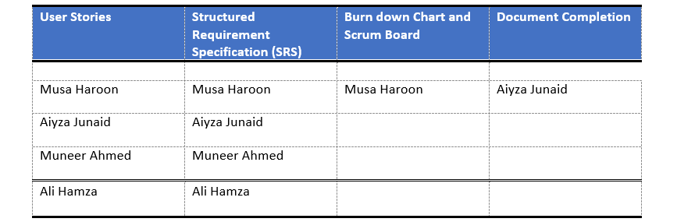

Iteration 2:

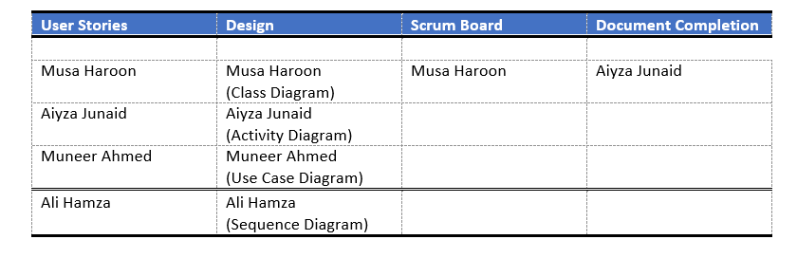

Iteration 3:

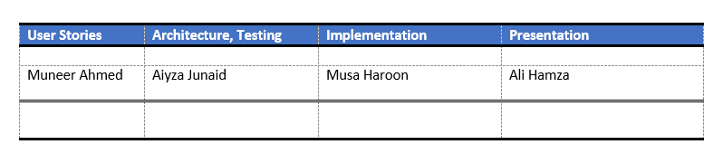

- Lesson Learnt by the Group:

As the team's leader, I've put the concepts of team leadership that I learned through my nano-degree in Leading Teams from the University of Michigan into practice. In addition, I've learned how to react in an emergency. How to lead people from various backgrounds and get them to work together as a team. As I was coordinating between the team and the instructor, I also developed coordination skills.

Communication is a very important part of teamwork. Working on this project, we all have learnt that good communication between all members can result in a stress free environment and a fruitful outcome. Working as a team we have learnt to listen to each other and identify strong points of each other which has helped us in assigning appropriate tasks to everyone in the group. Overall, we have learnt that knowing how to work in a group is an essential skill that we all should be equipped with because it will help us in our future professional lives.

==*-- THE END --*==

